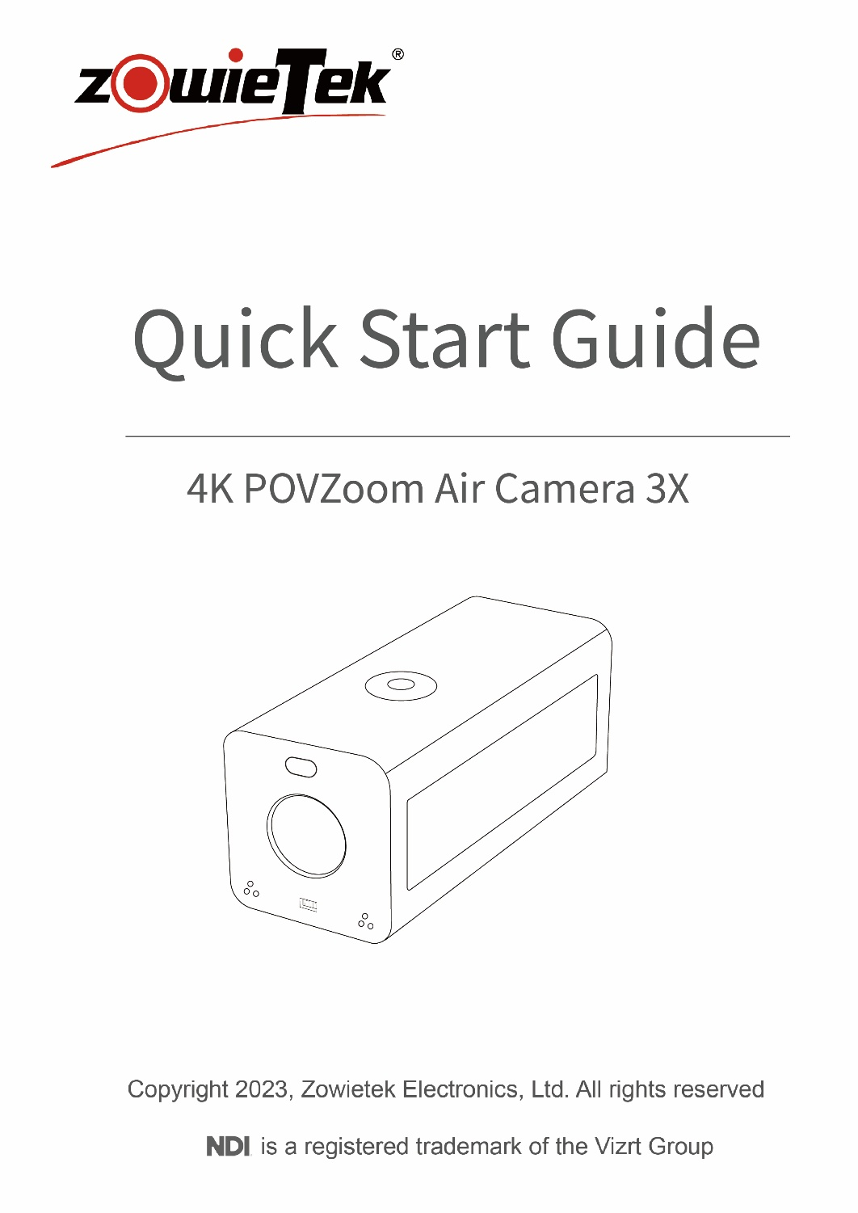

1. Packing List
Item | Unit | Quantity
POVZOOMAIR | PCS | 1
USB-C Power Adapter | PCS | 1
USB-C Cable | PCS | 1
Cold Shoe | PCS | 1
Quick Start Guide | PCS | 1

2. Device Interface Description
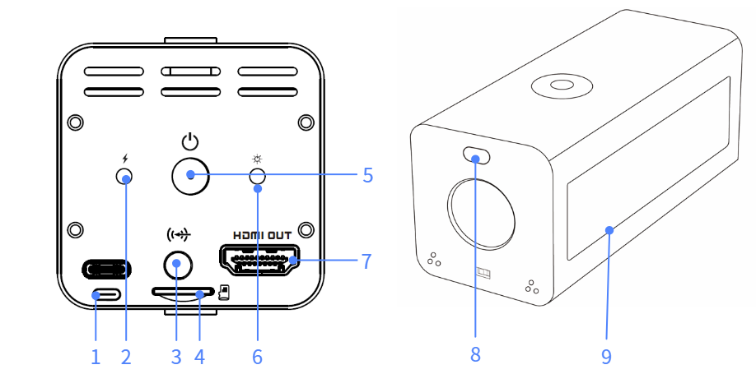

1 | USB-C Power Port | 6 | Status LED
2 | Charging LED | 7 | HDMI Out
3 | 3.5mm Audio In | 8 | Tally LED
4 | Micro SD Slot | 9 | LCD Touchscreen
5 | Power Button

3. Screen Display / Operation
The POVZOO AIR is equipped with an LCD touchscreen, allowing users to quickly view device status on the LCD and operate functions such as streaming, NDI, recording, and PTZ control via touch.

3.1 Dashboard Information
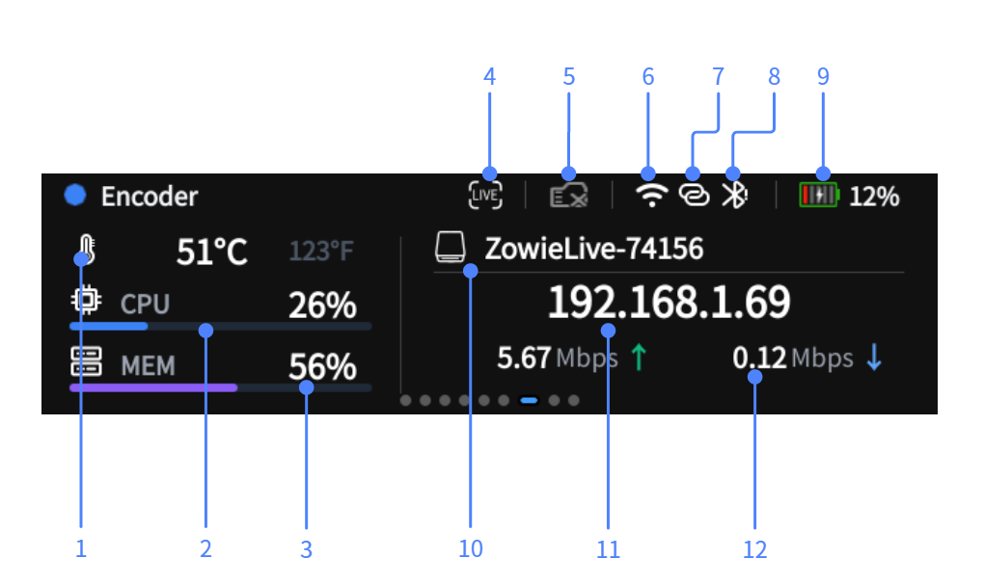

1 | CPU Temperature | 7 | Hotspot
2 | CPU Usage | 8 | Bluetooth Remote Status
3 | Memory Usage | 9 | Battery
4 | Streaming Status | 10 | Device Name
5 | Disk Status | 11 | IP Address
6 | Wi-Fi | 12 | Network Throughput

3.2 Basic Touchscreen Operations
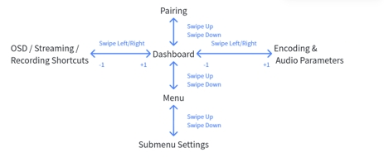

3.3 Touchscreen Quick Operations
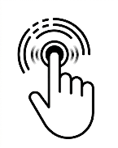 | Long press to bring up the quick access panel and perform LCD lock/standby/restart operations.
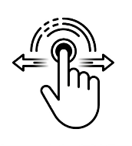 | Swipe from left to right / swipe from right to left to return to the Dashboard interface.

4.LED Status
There are three different LEDs on POVZOO AIR, corresponding to different functions.

4.1 Tally LED
The POVZOO AIR changes according to the operating status in auto mode.

Auto Mode | NDI Encoding
Green | NDI PVW
Red | NDI PGM/Streaming
Blue Flashing | Bluetooth APP Pairing
Yellow | Standby

4.2 Charging LED
Status | Color
Charging | White
Not charging / Charging complete | Off
Charging error | Flashing White

4.3 Status LED
Status | Color
No Power | Off
Powering On | Yellow
Standby | Slow Flashing Yellow
Upgrading / Disk Full / Recording Paused | Flashing Yellow
Streaming | Red
Ready | Green

5. Device Installation and Connection

5.1 Initial Charging Guide
When you receive the device for the first time, please use the original charger to fully charge it while the device is powered off.
When the device temperature exceeds °C, the device will stop charging.
For safety purposes, do not place the device on flammable surfaces or near heat sources while it is charging. If the battery indicator does not respond, disconnect the charger and contact customer support immediately. To prolong battery life, avoid completely draining the battery before recharging.

5.2 Power On/Off / Battery Check
 | Press 5 s | Press 10 s | Short Press
Powered On | Bring up the shutdown menu | Force shutdown | /
Powered Off | Power On | / | Check battery level

5.4 Login to the Web Console
POVZOO AIR supports multiple methods for Wi-Fi configuration.

1）Bluetooth Pairing
When the device enters the pairing interface, it will automatically enter Bluetooth pairing mode.
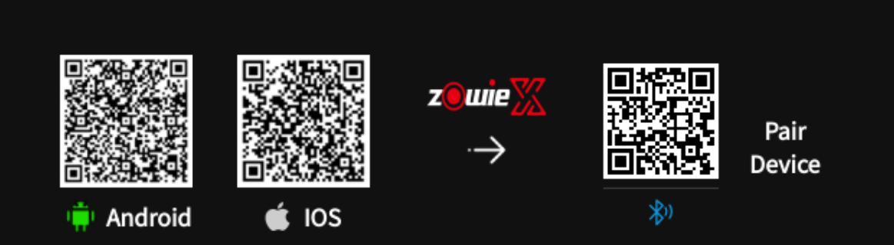
Please scan the QR code directly on the initial screen to download the corresponding ZowieX app.
ZowieX will automatically search for the device it was first paired with.
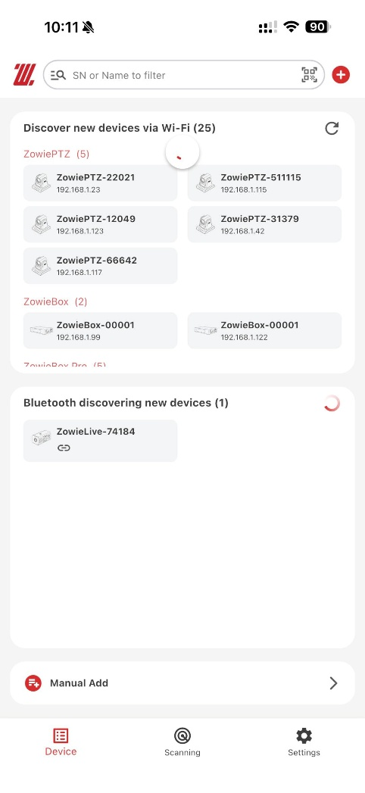

2) Hotspot Pairing
Please scan the QR code directly on the initial screen to download the corresponding ZowieX app.
Select the manual add ->POVZOOM AIR and scan the QR code on the far right to connect.
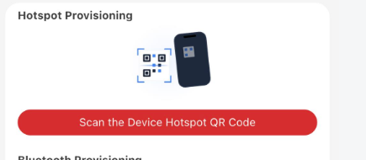

3）Manual pairing
The device's hotspot and password information are located on the back of the unit.
After manually connecting via mobile phone or computer, enter 170.128.88.1 into the browser to access the device's web console.

6. Remote Control

6.1 Button Functions
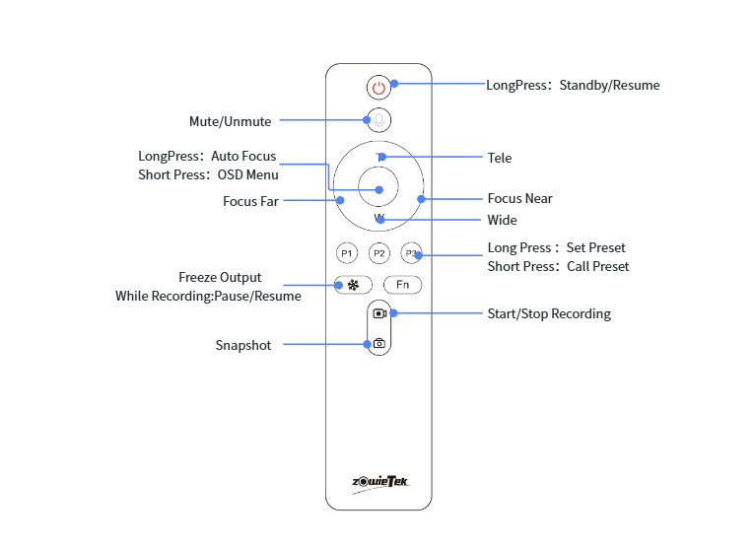

6.2 Pairing
When the remote control is not connected to the device, power-cycle it; the indicator light will flash, and the remote will enter pairing mode.

Method 1：
Log in to the device's web, navigate to Setting> Network > Bluetooth, locate the Bluetooth device with a name starting with "Zowietek," and click Connect.
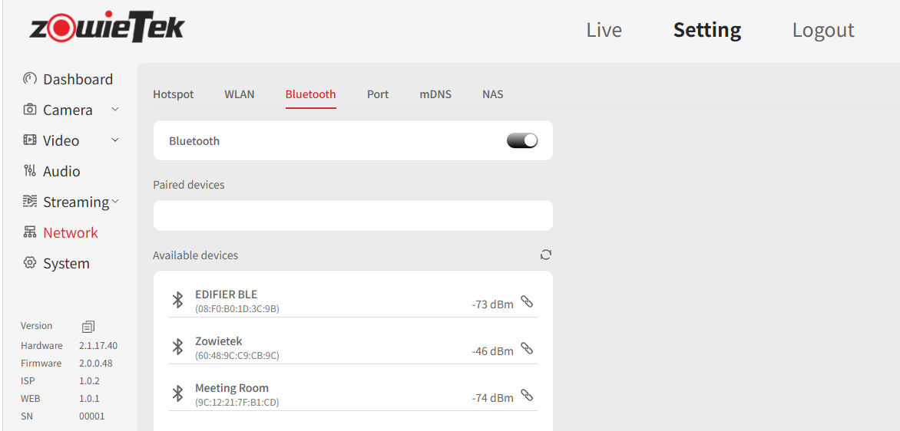

Method 2:
Use the LCD to navigate to Menu > Network > Bluetooth to enter remote control pairing mode; the system will automatically search for a remote control that has entered pairing mode.
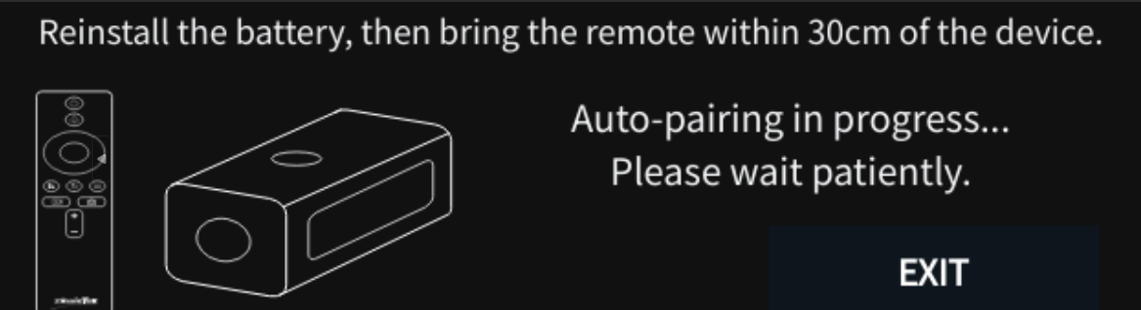

7. Quickly setting up a live streaming environment
Scenario 1: Live streaming directly using a single device connected to a mobile hotspot
Step 1: Open your phone's settings, enable "Personal Hotspot," and note down the hotspot name and password.
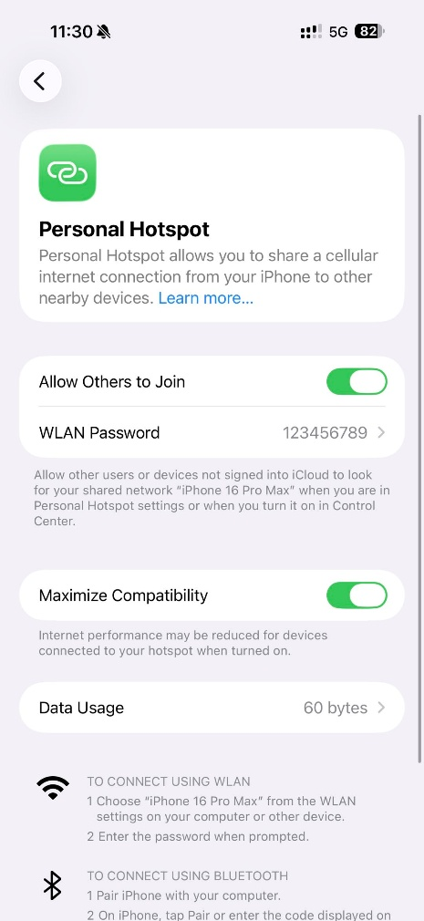
Step 2: Swipe down on the screen to enter Bluetooth pairing mode.
Open the ZowieX app on your phone and. ZowieX will automatically search for the device it was first paired with. Or click manual Add->POVZOOM AIR to manually search for Bluetooth devices.
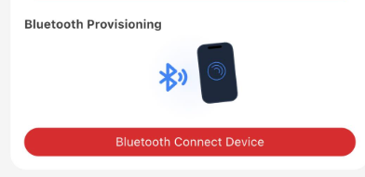
After connecting to POVZoom Air via Bluetooth, connect the device to your phone's hotspot.
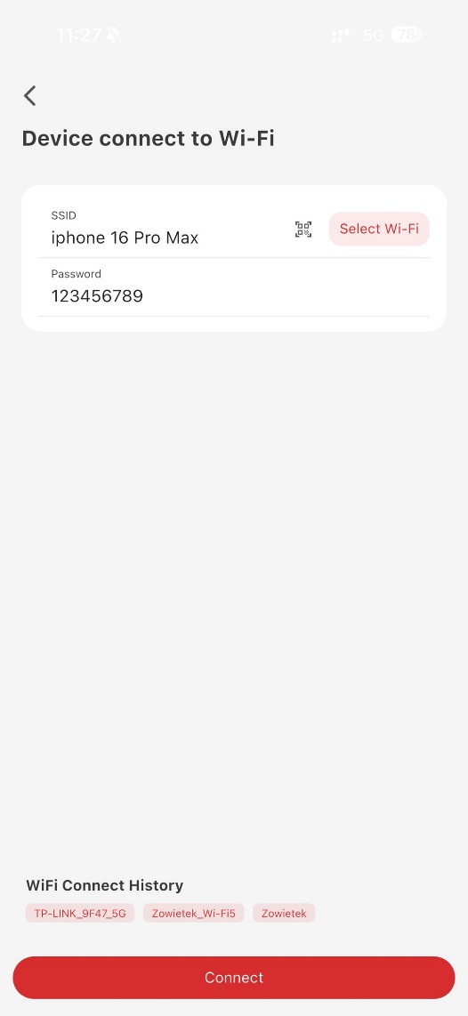
Step 3: Swipe the screen to confirm the device's IP address, then enter that IP address into your phone to access the device's web console. Navigate to Settings > Media Configuration >WLAN Stream to configure the streaming URL.
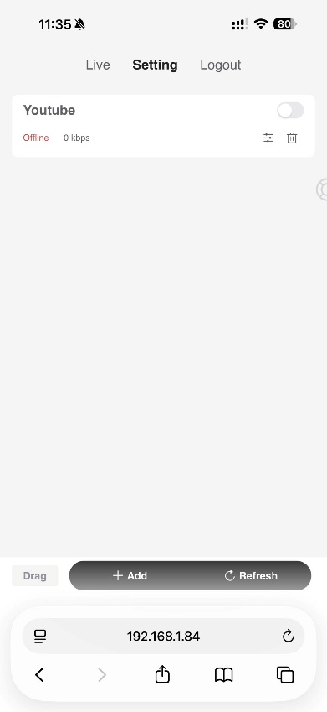

Scenario 2: Multiple devices and an iPad simultaneously connecting to a mobile hotspot for live streaming
Step 1: Connect the devices to the mobile hotspot following the method described in Scenario 1.
Step 2: Turn on the iPad's Wi-Fi and connect it to the same mobile hotspot.
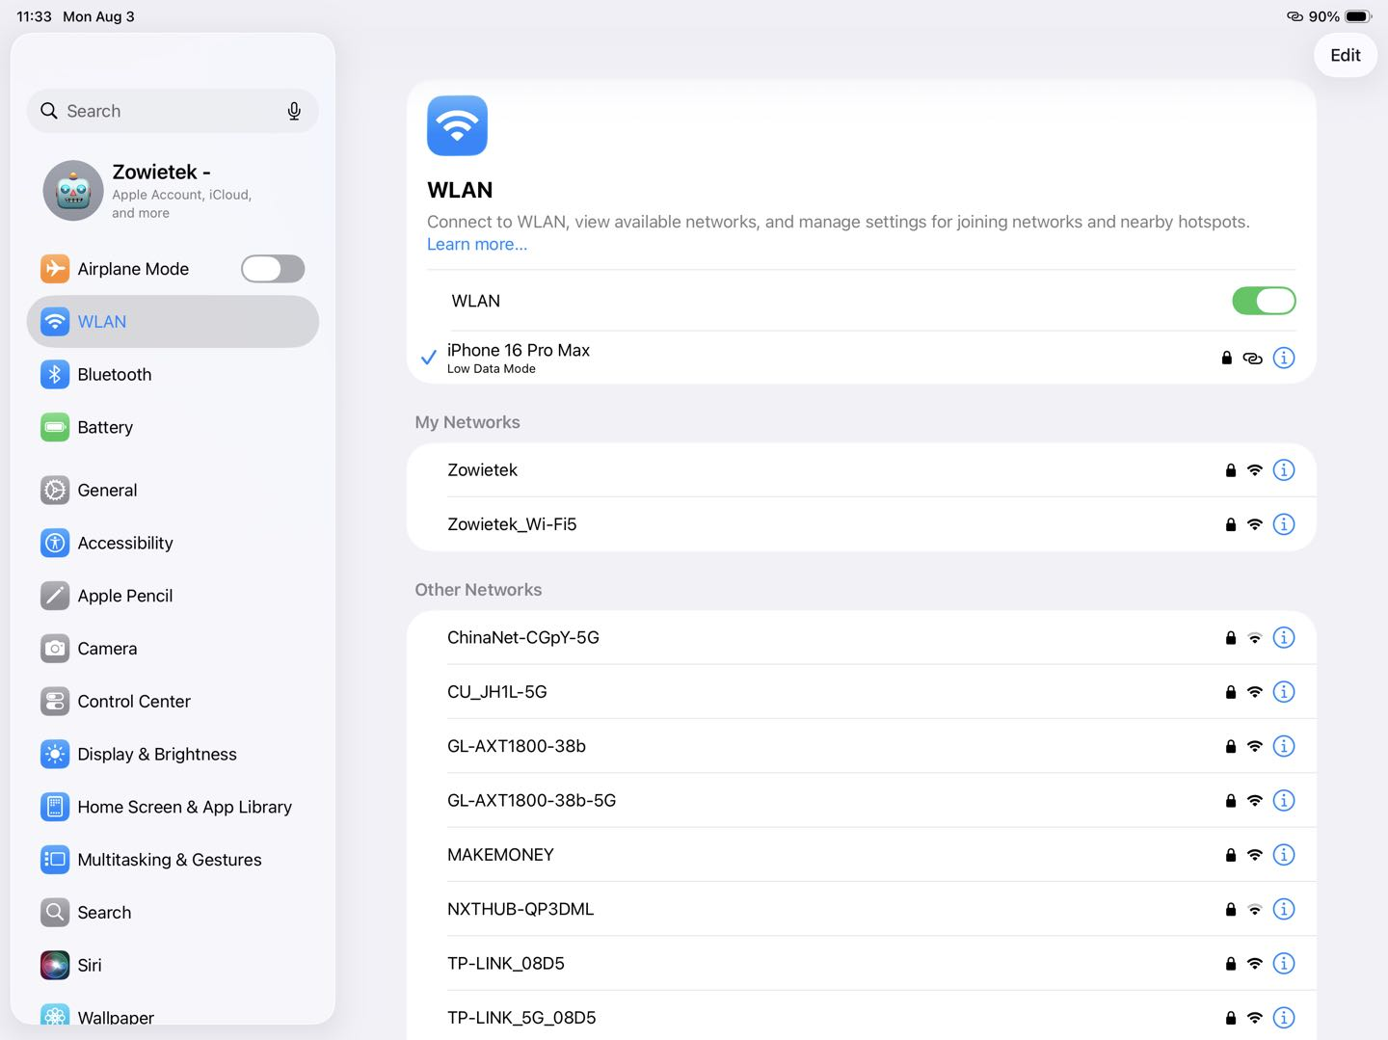 Step 3: Open the live production software (such as "Top Director") on your iPad, use RTSP, SRT, or NDI to ingest the stream from the device into the software, and then proceed with live production and streaming.
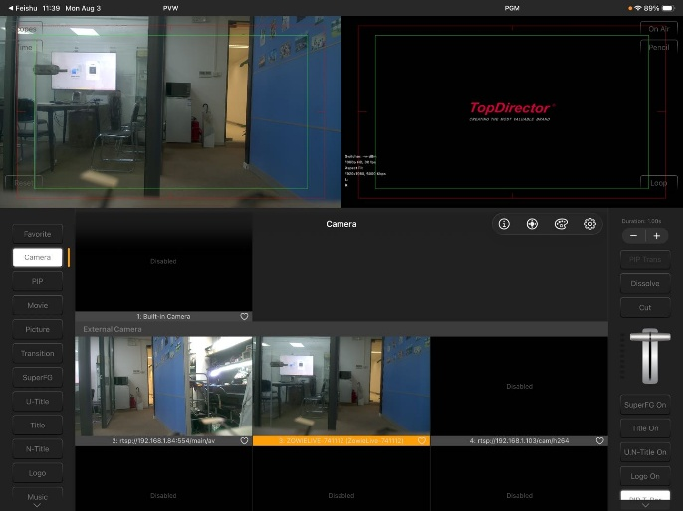
Scenario 3: Live streaming using a portable router
Step 1: Connect your phone to the router's Wi-Fi and log in to the router's admin interface (the login IP address is usually found on the bottom of the router).

Step 2: Depending on the router's features, select either the USB or wireless method to connect the router to your phone's hotspot.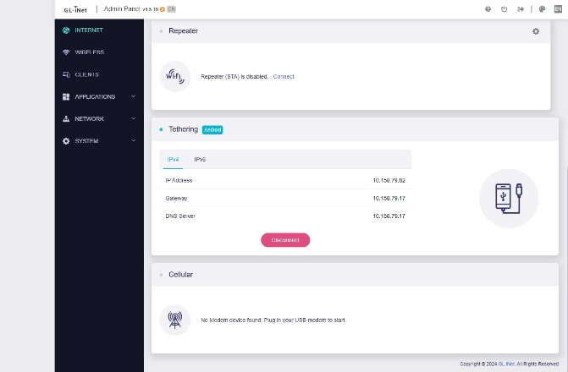
Step 3: Connect POVZOOM Air to the router's Wi-Fi, following the method described in Scenario 1.
Step 4: Connect the iPad to the same router Wi-Fi network.
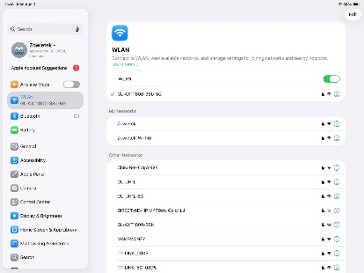
Step 5: Open the live production software (e.g., Director) on the iPad, ingest the stream from the device using RTSP, SRT, or NDI, and then proceed with production and streaming.
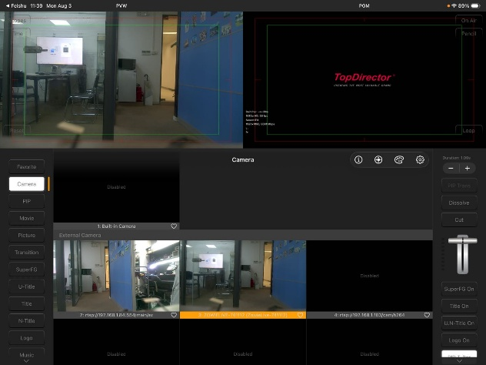

7. Firmware Upgrade

Method 1:
1) Log into the web control interface, click "System Setting > Firmware Upgrade".
2) Click "Upload" to upload the correct firmware file.
3) Click "Upgrade".
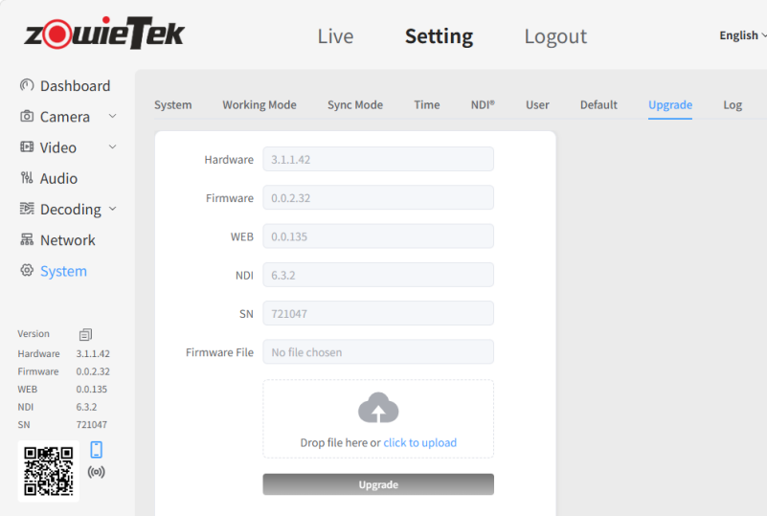

Method 2:
- Select TF card formatted as FAT32/exFAT.
- Extract the upgrade firmware to the root directory of the TF card. Power off and restart POVZOO AIR.

8. Restore Factory Settings

Method 1:
Use the LCD touchscreen to restore the device to factory settings in the system settings.
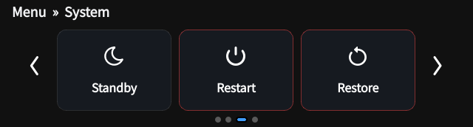

Method 2:
Log in to the web control interface, click Setting-> System ->Default.
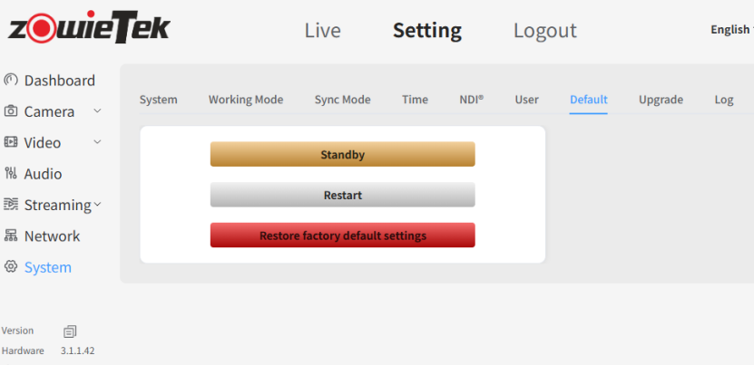

9. Warranty
We offer you POVZOO AIR
One-year hardware warranty
Lifetime software warranty

For answers to FAQs and information, please visit:
 | https://www.zowietek.com/knowledge-base
 | https://www.zowietek.com/
Or contact us:
 | support@zowietek.com
 | +86-21-50277371, 50277372

 | https://www.linkedin.com/company/zowietekelectronics
 | https://www.youtube.com/@zowietekelectronics
 | https://www.facebook.com/ZowieX
 | https://www.instagram.com/zowietek

A professional
video camera,
streaming, and recording
solution provider
Since 2004

Zowietek Electronics, Ltd.
Manufacturing Operations Center (Headquarter):
No. 6818 Daye Road, 5#D501
Fengxian, Shanghai 201403, China

R&D Center:
BHC West Wing 17F01,
No. 2218 HuNan Road, Pudong, Shanghai 201204, China
PN: 30721-XYZ

is a registered trademark of Zowietek Electronics, Ltd.

